**Pseudo Code: Encryption Algorithm**

SET encrypted to password

CALCULATE effectiveShift as (shift + salt) modulo 26

FOR each character c in encrypted:

IF c is a letter:

SET base to 'a' if c is lowercase, otherwise 'A'

REPLACE c with: ((c - base + effectiveShift) modulo 26) + base

RETURN encrypted

**Pseudo Code: Salt Number Algorithm**

CREATE a random device called r

GENERATE a random number using r

RETURN the random number modulo 1,000,000

**Encryption Flowchart Algorithm**

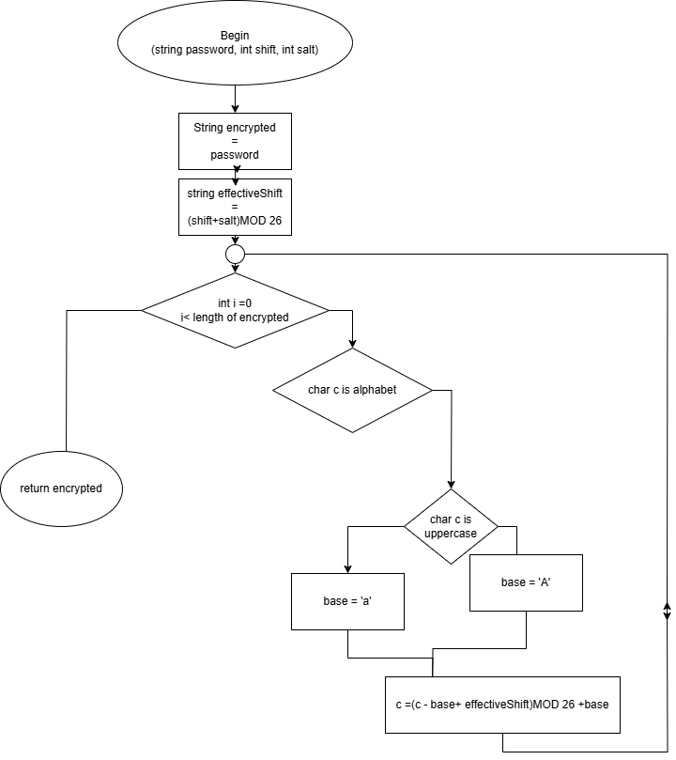

**Salt Number Algorithm**

